Important feature in the coming version is make budget for project based on the tender study in contracting system and compared it to project actual expenses, I think this point asked in demos many times.

In this screen we can get study for how much this project will cost me of salary, labors expenses, steels, fixed assets depreciations,….etc

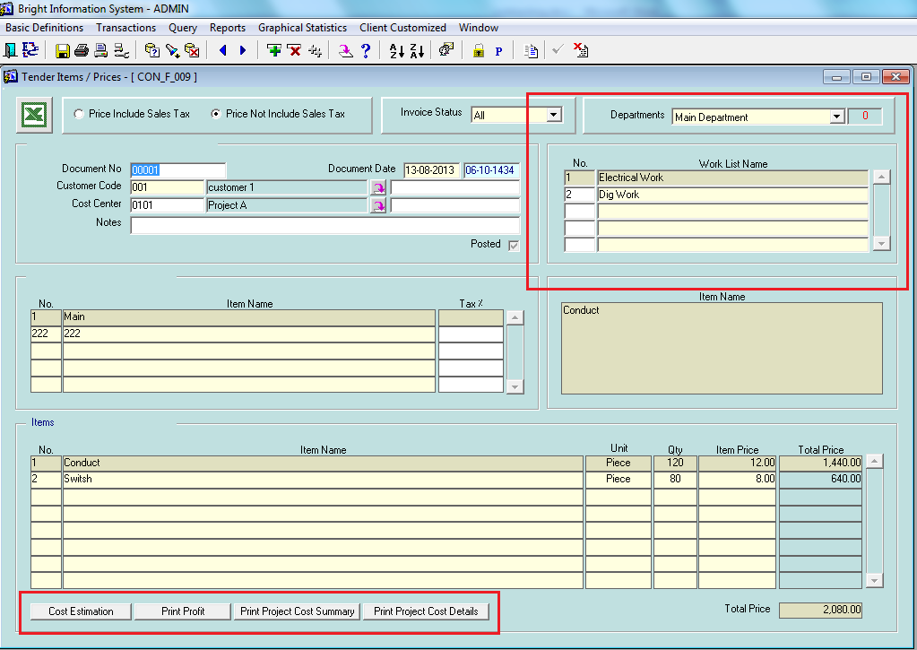

We assign each point in the tender to our expense in chart of account

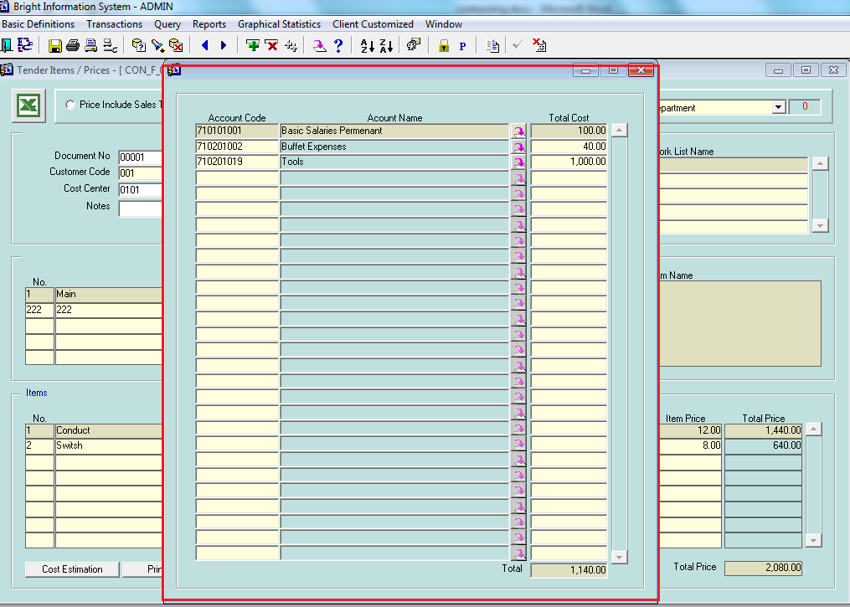

The system after that can print the total cost of the project as a study report; in the contract form we will use this study to turn it into budget.

The system will calculate estimated project total cost automatically and shows how much this project will cost of salary, labors expenses, steels, fixed assets depreciations,….etc

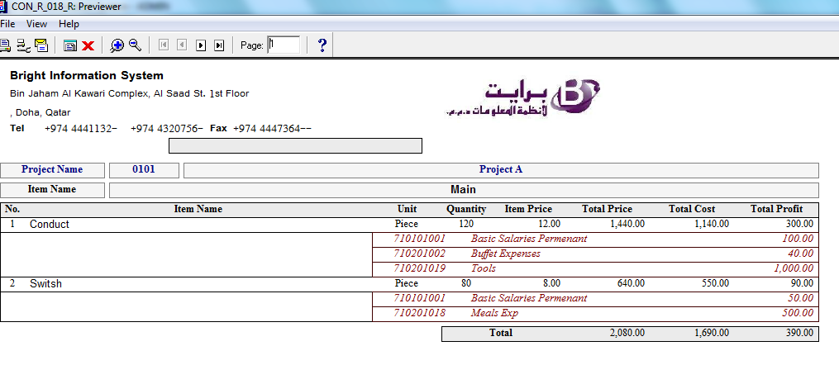

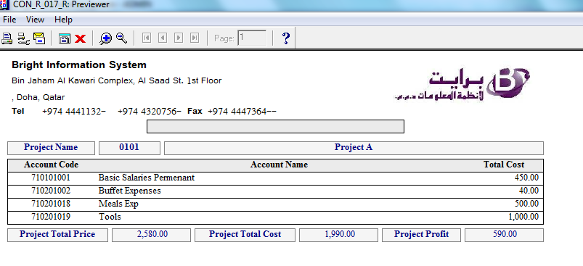

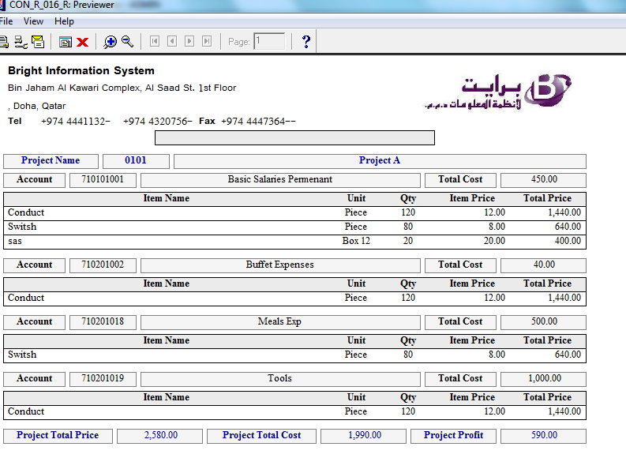

By pressing the create budget button the system will create the budget and we can also increase the budget later on based on another contract attached.

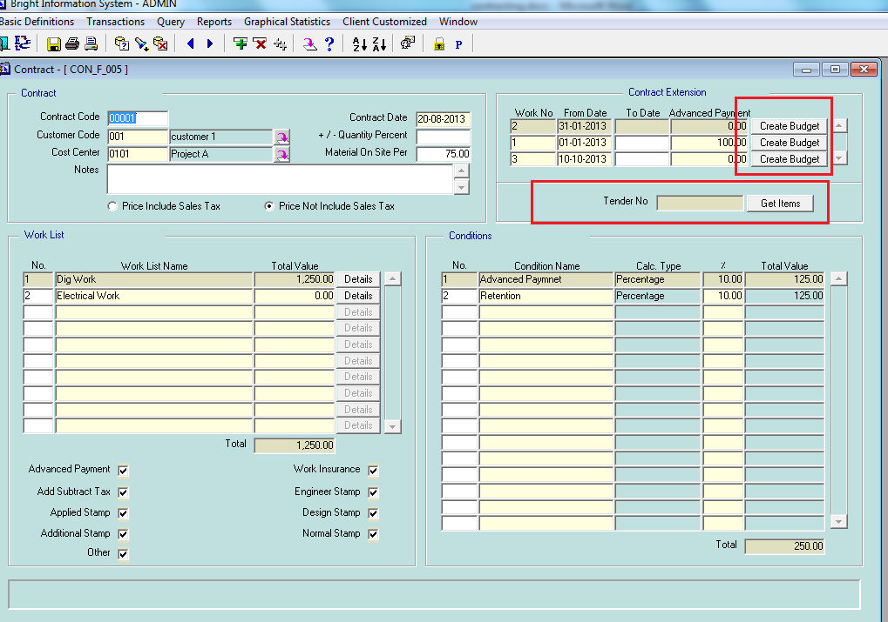

System will create the budget as shown

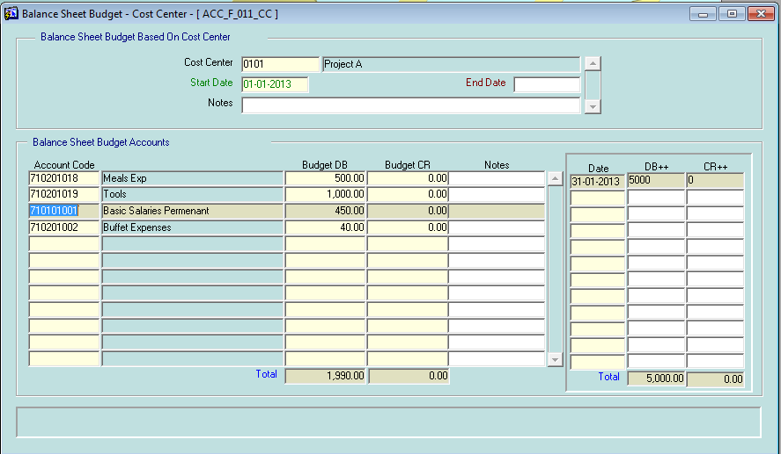

And the system will compare the project budget to actual expenses as shown

